**Plots & Results DRAFT ☺** ***Ghofran & Adi***

**NOTE: The first three plots were created to present the data and provide a general overview of the dataset. They illustrate the distribution of participants by age, gender, and diagnosis status, helping to understand the structure and balance of the dataset before diving into deeper analysis**.

**Plot 1:**

The graph shows the **age distribution** of patients in the dataset.

The main goal is to understand how ages (from 60 to 90) are distributed and the number of patients in each age group.

**Plot 2:**



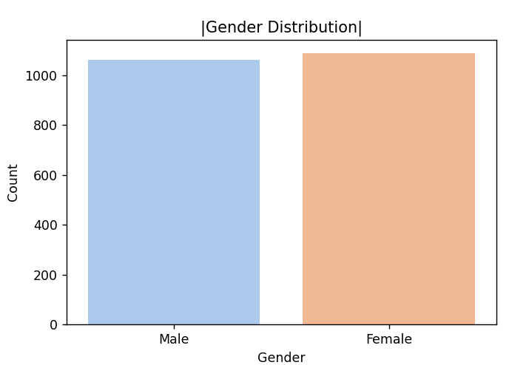

The graph shows the **gender distribution** in the dataset.

**Blue bar (Male):** Represents the count of male participants.

**Peach bar (Female):** Represents the count of female participants.

The dataset is **balanced in terms of gender**, with nearly equal numbers of males and females. This balance ensures that any gender-related analysis will not be biased by an overrepresentation of one gender.



**Plot 3:**

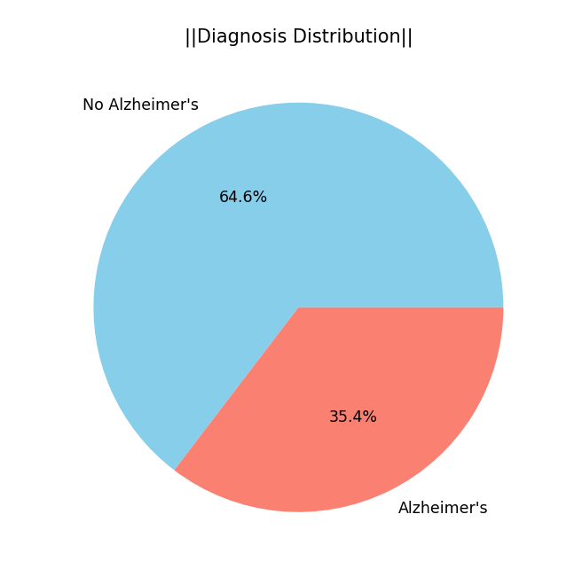

The pie chart represents the **diagnosis distribution** in the dataset.

**Blue section (64.6%):** Participants without Alzheimer's.

**Red section (35.4%):** Participants diagnosed with Alzheimer's.

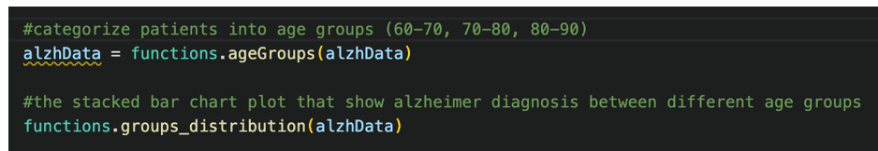

**Plot 4:**

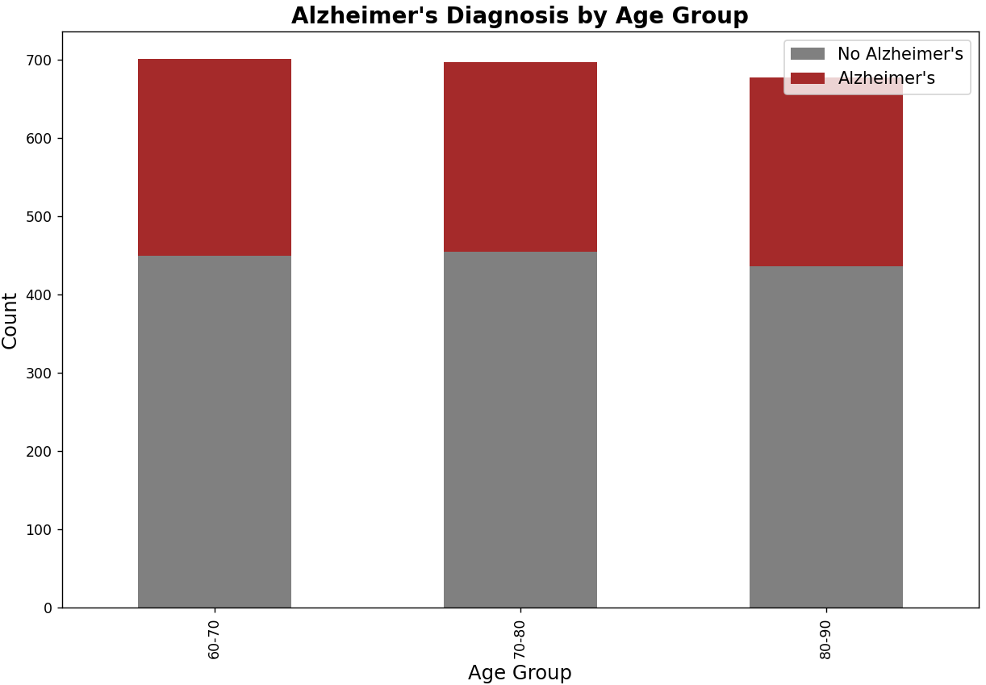

The bar chart shows the distribution of Alzheimer's diagnoses across different **age groups** (60-70, 70-80, 80-90).

**Gray sections:** Represent patients without Alzheimer's.

**Red sections:** Represent patients diagnosed with Alzheimer's.

This small difference indicates that age could be a contributing factor to Alzheimer's but might not be the sole determining factor.

**Plot 5:**

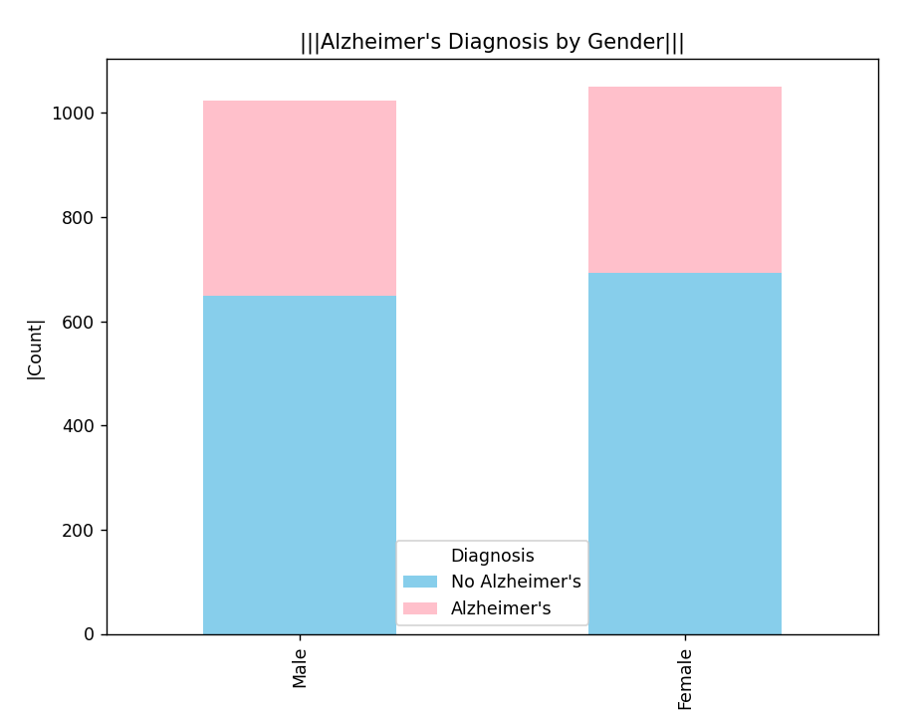

The bar chart shows the distribution of Alzheimer's diagnoses by **gender**.

**Blue section:** Represents patients without Alzheimer's.

**Pink section:** Represents patients diagnosed with Alzheimer's.



**Plot 6:**

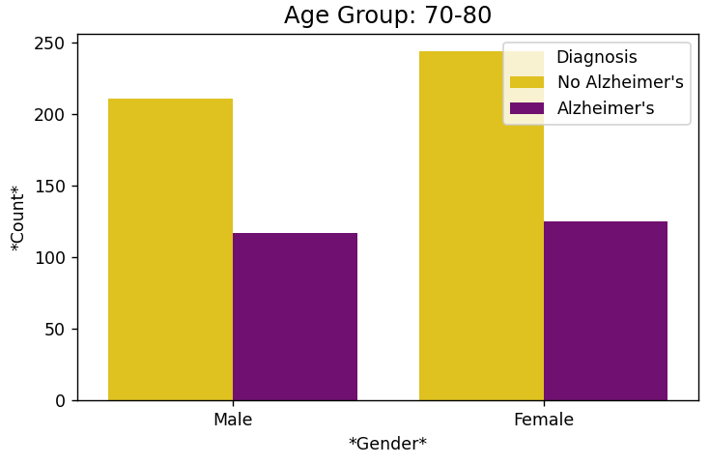

This bar chart focuses on the **age group 70-80** and shows the distribution of Alzheimer's diagnoses by **gender**.

**Yellow bars:** Represent individuals without Alzheimer's.

**Purple bars:** Represent individuals diagnosed with Alzheimer's.

The proportion of females diagnosed with Alzheimer's is slightly **higher** than that of males.

**Plot 7:**

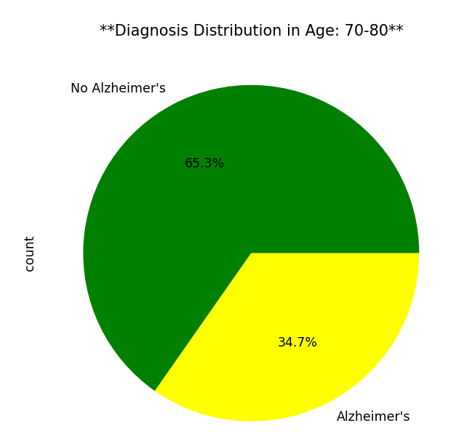

**Majority Without Alzheimer's:** In the age group 70-80, **65.3%** of individuals do not have Alzheimer's.

**Significant Proportion With Alzheimer's:** **34.7%** of individuals in this age group are diagnosed with Alzheimer's, which is a significant proportion but still smaller than those without the disease.

**Plot 8:**

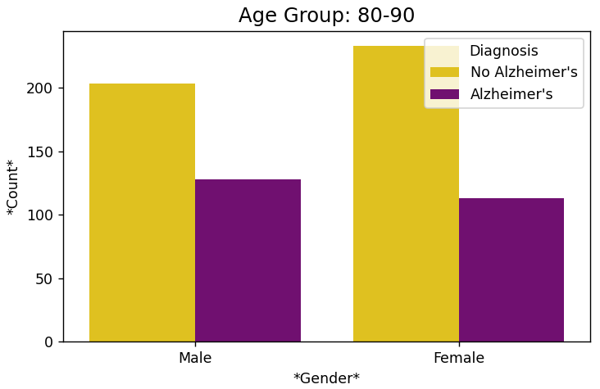

The proportion of males diagnosed with Alzheimer's is slightly **higher** than that of females in this age group.

**Plot 9:**

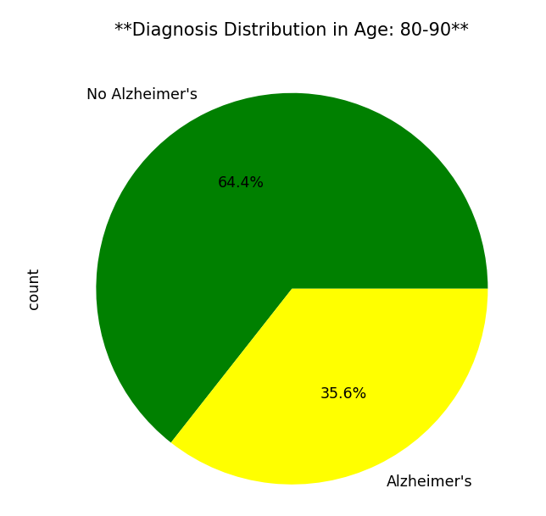

This pie chart shows the **diagnosis distribution** for the **age group 80-90**.

**Green section (64.4%):** Represents individuals without Alzheimer's.

**Yellow section (35.6%):** Represents individuals diagnosed with Alzheimer's.

**Majority Without Alzheimer's:** In the age group 80-90, **64.4%** of individuals do not have Alzheimer's.

**Notable Proportion With Alzheimer's:** **35.6%** of individuals in this age group are diagnosed with Alzheimer's, which is slightly higher than in younger age groups (e.g., 70-80).

**Plot 10:**

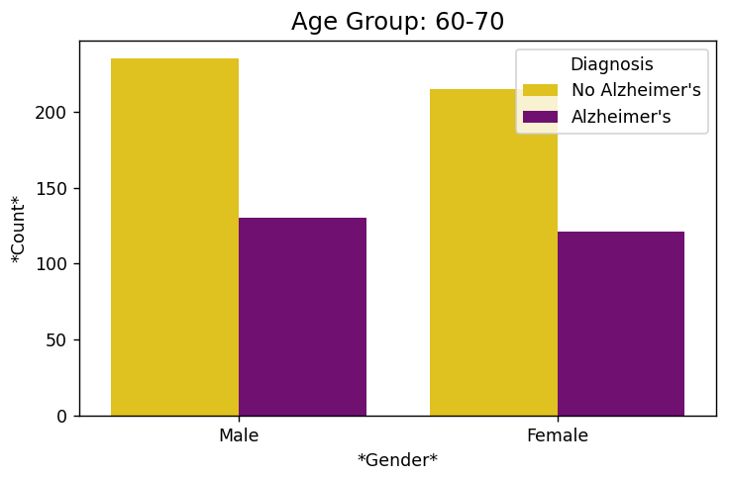

The proportion of males diagnosed with Alzheimer's is slightly **higher** than that of females in this age group.

**Plot 11:**

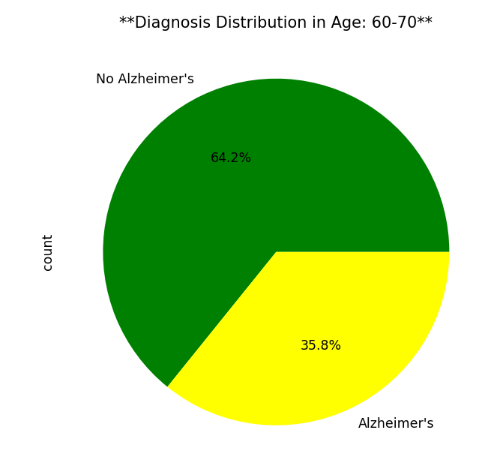

This pie chart shows the **diagnosis distribution** for the **age group 60-70**.

**Green section (64.2%):** Represents individuals without Alzheimer's.

**Yellow section (35.8%):** Represents individuals diagnosed with Alzheimer's.

**Majority Without Alzheimer's:**

In the age group 60-70, the majority of individuals (**64.2%**) do not have Alzheimer's.

**Significant Proportion With Alzheimer's:**

However, a notable **35.8%** of individuals in this age group are diagnosed with Alzheimer's.

**Plot 12:**

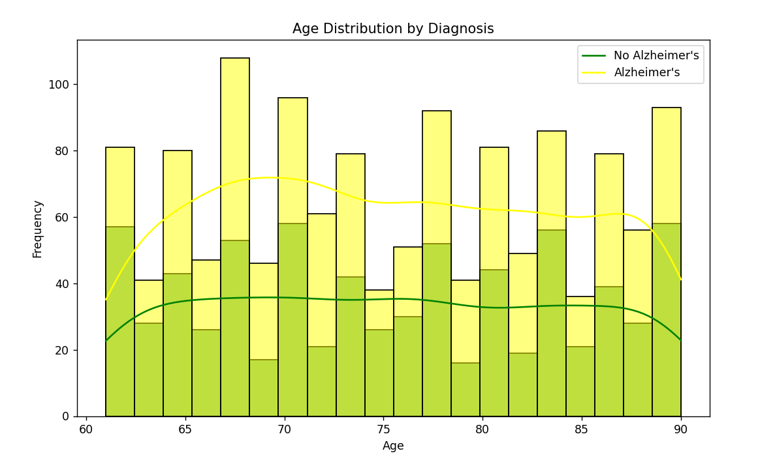

This graph visualizes the **age distribution** of individuals in the dataset, categorized by their Alzheimer's diagnosis. **Green bars:** Represent the count of individuals **without Alzheimer's** at each age. **Yellow bars:** Represent the count of individuals **with Alzheimer's** at each age. **Green line:** Shows the overall trend of individuals without Alzheimer's across different ages. **Yellow line:** Shows the overall trend of individuals with Alzheimer's across different ages. **Patients Without Alzheimer's (Green Bars and Line):** The green bars remain relatively consistent across all age groups, indicating that the number of individuals without Alzheimer's does not vary significantly with age. The green trend line is relatively flat, confirming this consistency. **Patients With Alzheimer's (Yellow Bars and Line):** The yellow bars and trend line peak around age **67**, indicating a higher prevalence of Alzheimer's in this specific age.  
After this peak, the yellow line gradually declines as age increases beyond **67**.

*While the peak at* ***age 67*** *indicates a slightly higher prevalence of Alzheimer's,* ***the difference is not very significant*** *compared to other ages. Across all age groups, the number of individuals without Alzheimer's remains* ***consistently higher****, and the variation in the prevalence of Alzheimer's is relatively small.*

**Outputs:**



This message indicates that the dataset does not contain any missing values in any of the columns that were checked.

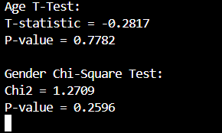

**Age T-Test: T-statistic = -0.2817** The negative value indicates that the **average age of individuals with Alzheimer's is slightly lower than the average age of individuals without Alzheimer's**. However, because the value is very close to zero, the difference in means is minimal and practically insignificant. **P-value = 0.7782** This means that the difference in average age between the two groups (with and without Alzheimer's) is **not statistically significant**. In other words, the observed difference could easily be due to random chance.

While the negative T-statistic suggests a slight trend where Alzheimer's individuals may have a slightly lower average age, this difference is **not meaningful or statistically significant**.

**Gender Chi-Square Test: Chi2 = 1.2709** This measures the relationship between gender and Alzheimer's diagnosis. The low value indicates a very weak association. **P-value = 0.2596** Since this is greater than 0.05, there is **no statistical evidence** of a relationship between gender and Alzheimer's diagnosis.

***So…***

***"Does age and gender have an effect on Alzheimer's diagnosis?"***

**Age:** The visualizations (e.g., age distribution and trends) showed a slight variation in Alzheimer's prevalence with age, peaking around **67 years old**. However, the **T-test for age** revealed no statistically significant difference between the average ages of individuals with and without Alzheimer's (P-value = 0.7782). So, Age does not have a statistically significant effect on Alzheimer's diagnosis based on this dataset.

**Gender:** The gender-based analysis showed a nearly equal distribution of Alzheimer's cases between males and females. The **Chi-Square test for gender** confirmed no statistically significant association between gender and Alzheimer's diagnosis (P-value = 0.2596). So, Gender does not have a statistically significant effect on Alzheimer's diagnosis based on this dataset.

***Final answer (Finally ☺):***

***Both age and gender do not show a significant effect on Alzheimer's diagnosis according to the statistical tests and the dataset used. While slight patterns were observed visually, they are not strong enough to draw conclusive evidence.***